MODULE 4 – INTRODUCTION TO DBMS

LAB EXERCISES

7. Data Manipulation Language – DML
Lab 1.
Insert three new authors into the authors table, then update the last name of one of the authors.
Ans.
1. insert records
INSERT INTO authors(author_id, first_name, last_name, country) VALUES (1, 'Richa', 'Parmar', 'USA'),
(2, 'Purvi', 'Rathod', 'UK'),(3, 'Vaibhav', 'Jadeja', 'USA');
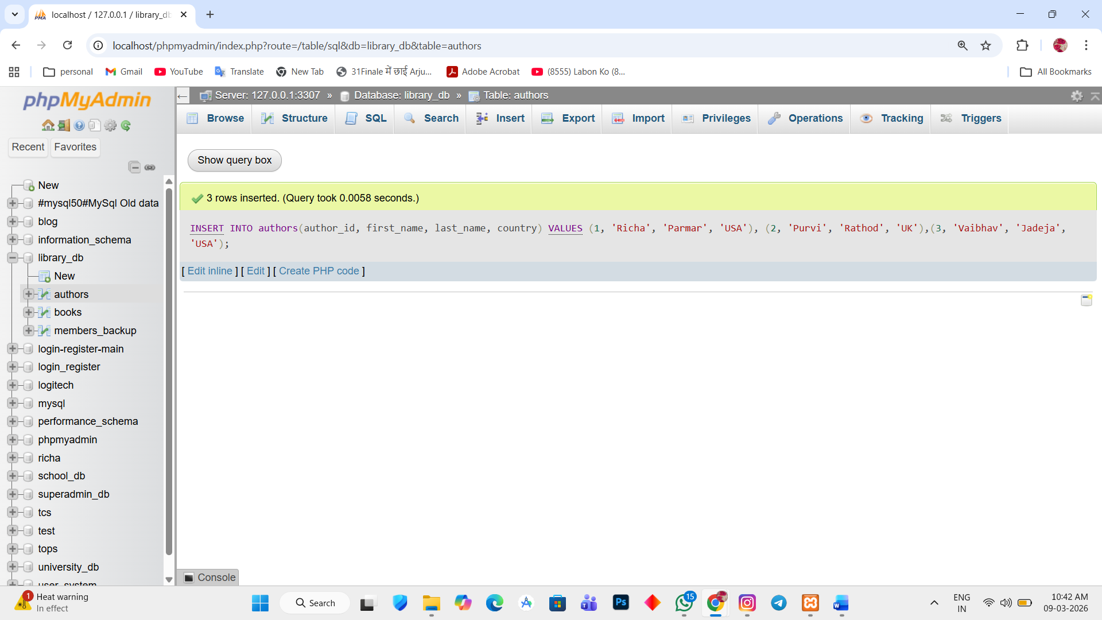

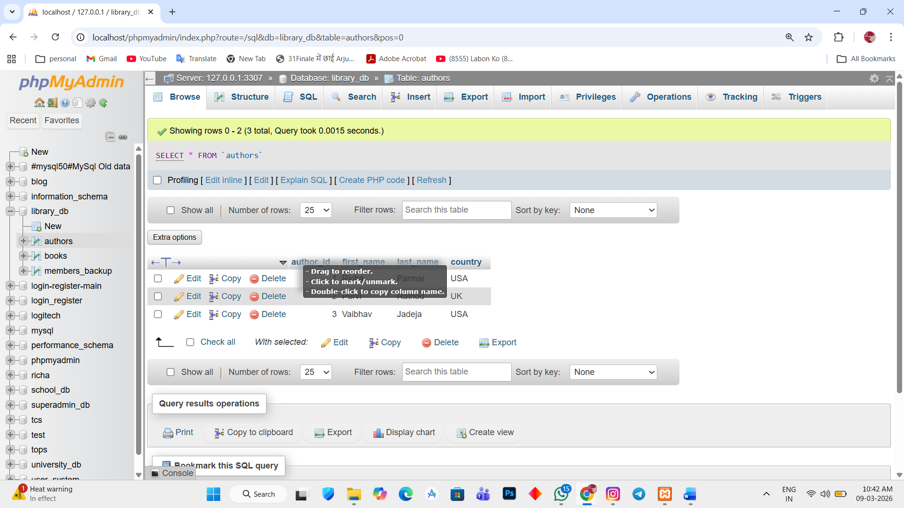

Update the last name of the author
2. UPDATE authors SET last_name = 'Ahir' WHERE author_id = 3;

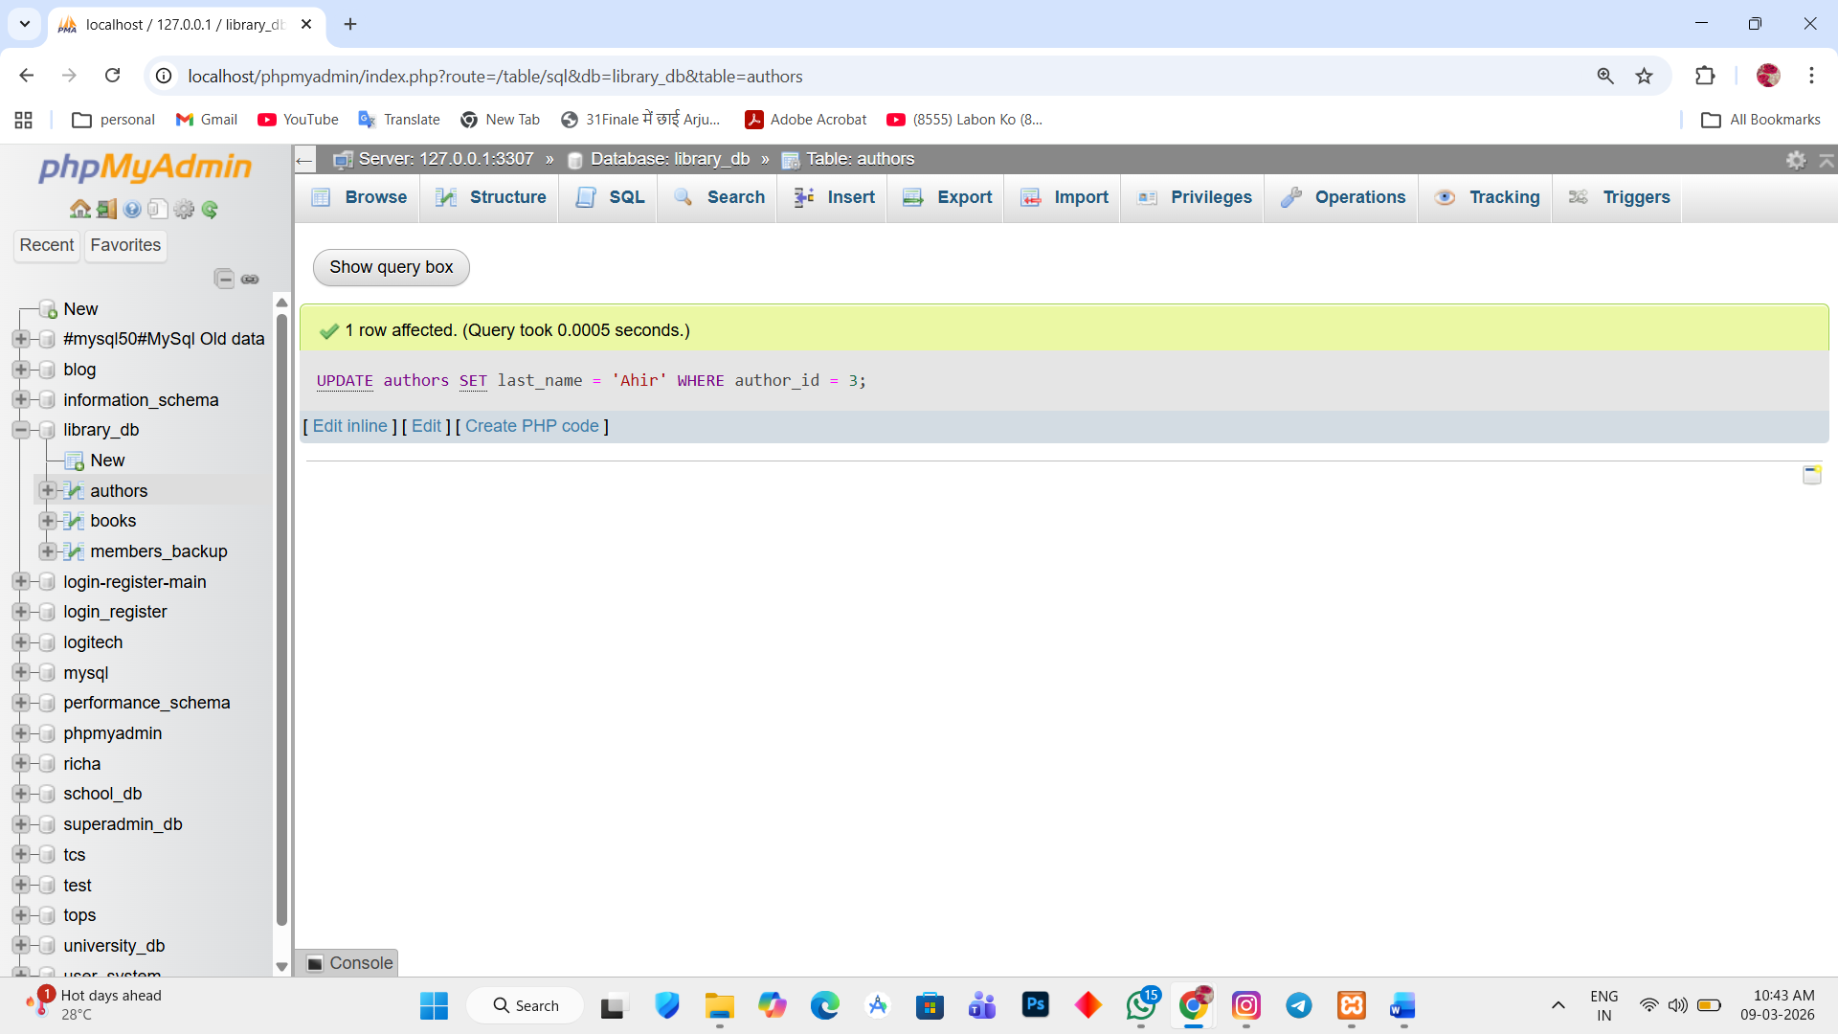

Lab 2.
Delete a book from the books table where the price is higher then $100.
Ans.
1. Update the details
UPDATE books SET price = 90 WHERE book_id = 1;
UPDATE books SET price = 50 WHERE book_id = 2;
UPDATE books SET price = 80 WHERE book_id = 3;
UPDATE books SET price = 190 WHERE book_id = 4;
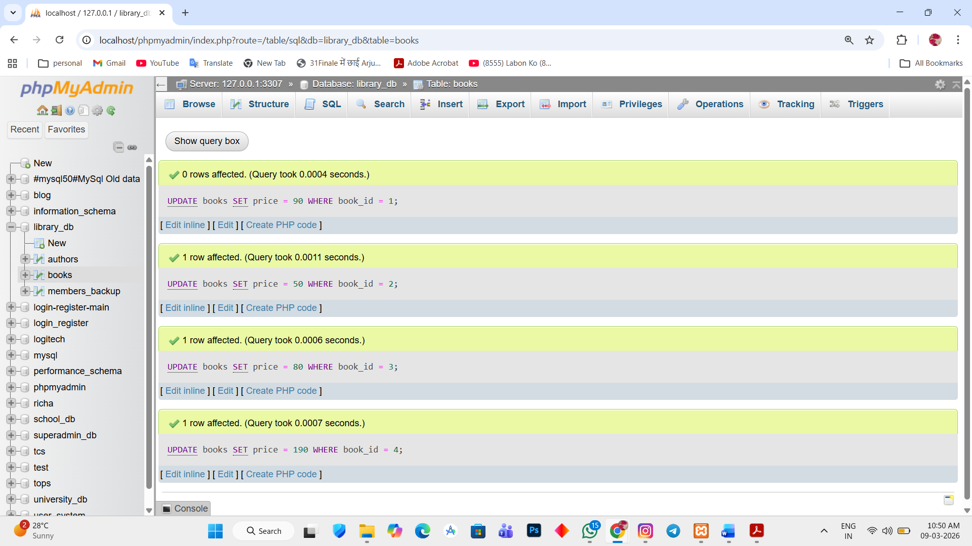

Delete a book
2. DELETE FROM books WHERE price > 100;

